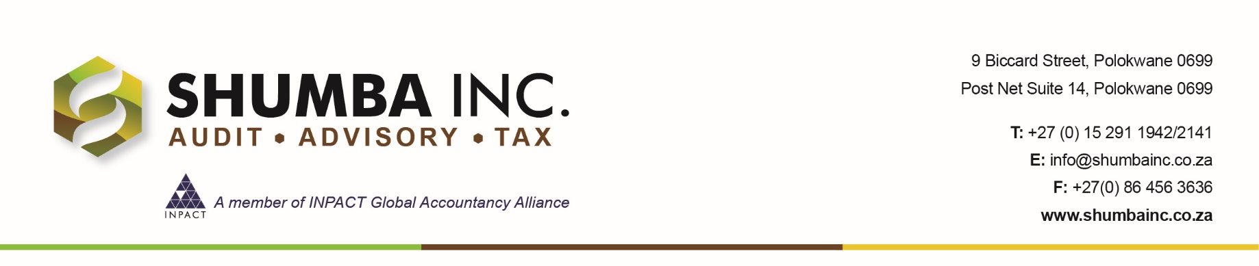

DECLARATION BY STAFF MEMBERS THAT THEY HAVE ACCESS TO THE POLICIES AND PROCEDURES MANUAL

I ……………………………………………………………. confirm that:
I know where the firm’s electronic Quality Management System Manual is stored on our computer network, and the path is [https://shumbalink.ituzatech.co.za/]
I have read and understand the firm’s new Quality Management System AND Ethics Manual (issued and approved on [07 December 2022] containing policies and procedures relating to independence and relationships and understand that quality control and being ethical is an integral part of Auditing and Assurance, at both the firm and individual audit level.
I confirm that I have attended a training session/meeting held on [08 December 2022] to specifically communicate the Quality Management System and ethics and independence policies and procedures to all audit and assurance staff.
I agree to take personal responsibility for quality and ethics, and I understand that I am expected to comply with these policies and procedures.
I undertake to utilise our firm’s standard documentation as set out in the Quality Management System (including the Annexures thereto) as well as the working paper file templates.
I undertake to actively promote and implement quality and be ethical in the execution of my daily duties.
I understand that contravention of these Quality Management System and Ethics Policies and Procedures may lead to disciplinary action in terms of our firm’s Code of Conduct.
I will communicate any queries in this regard to HR manager

_____________________________________
Signature

_____________________________________
Date

